UKHSA guidelines for Teams meeting backgrounds
As professional government employees we should be using appropriate backdrops for Teams meetings when working in an official capacity. You may consider using one of the official UKHSA Teams backgrounds in such instances. Currently available ones are shown below. For best results you should have some kind of light source in front of you.

How to use the background files
Open up your teams calendar, select an old meeting and click join (you won't actually be joining the meeting). This brings up the 'pre meeting’ window where you can see yourself (assuming that your camera is turned on). Underneath the camera image it says 'Background filters'. Click on that and it will show you all the built in backgrounds. At the very top click on 'Add new'. Navigate to where you put the image files. Select one and now it will appear in the background, and it will also be selectable in the future from the bottom of the built-in images. To remove or change a background, click on 'Background filters' again, and either add a new one, select one from those available, or click the top one which has a circle with a line through it to remove the current image. Your selected image will remain until you change or remove it.

The files are available from Branding@phe.gov.uk or they can be downloaded from https://khub.net/web/phe-national/public-library/-/document_library/v2WsRK3ZlEig/view/603194899?_com_liferay_document_library_web_portlet_DLPortlet_INSTANCE_v2WsRK3ZlEig_redirect=https%3A%2F%2Fkhub.net%3A443%2Fweb%2Fphe-national%2Fpublic-library%2F-%2Fdocument_library%2Fv2WsRK3ZlEig%2Fview%2F603182956

Current UKHSA backgrounds

UKHSA Teams background flat teal | UKHSA Teams background mottled teal
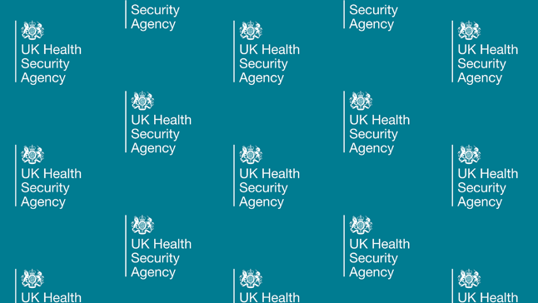 | 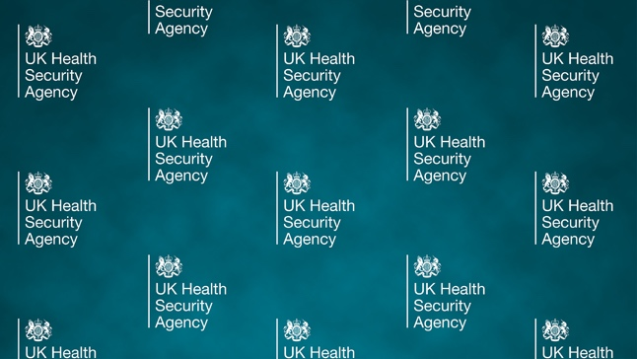
UKHSA Teams background flat grey | UKHSA Teams background mottled grey
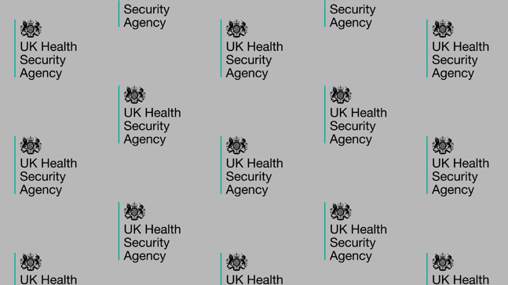 | 