Digital, Data and Technology (DDaT) Profession
Starter pack

Provided by the Government Digital Service, DDaT Capability Profession team
Version 1.0 - May 2020

Introduction

Building capability across government
Building digital, data and technology capability across government is a priority of the Government Transformation Strategy.

The Digital, Data and Technology (DDaT) Profession team in the Government Digital Service (GDS, a business unit of the Cabinet Office) has developed a number of cross government strategies to help organisations attract, recruit and retain the right people and skills.

The aim is to find ways to solve common capability problems once for everyone in government.

This starter pack is designed to help Capability Leads, HR Business Partners and Pay & Reward Leads across government, understand how to implement these strategies and to discover what's available to enable your teams to benefit from doing so.

We have lots of useful and practical guidance, DDaT career paths and case studies on capability assessment and more. If you’re new to all this, please allow the pack to explain where to find it all or if you have a specific interest use the summary contents links below to take you to the details you’re looking for.

Each section in this document provides some introductory information and the links to relevant materials on Knowledge Hub.
You’ll need to sign up to Knowledge Hub so that you can access DDaT Capability resources by following the links in this document.

Digital, Data and Technology (DDaT) Profession resources
This is a collection of resources hosted on Knowledge Hub created by the DDaT Profession Capability team at the GDS for use by:

- DDaT Profession Leads (single points of contact: SPoC)
- Capability Leads
- HR Business Partners
- Pay & Reward Leads
- Heads of roles within organisations
- Heads of Communities of Practice.

Most of our materials can be shared with your teams directly, so please forward these on to people involved in supporting DDaT professionals. However, please also follow the handling instructions for items that are marked OFFICIAL-SENSITIVE, such as pay & reward guidance or workforce commission insights.

- Details on how to sign up to Knowledge Hub, to see what's available.

Summary of contents
The DDaT Profession team
The DDaT Capability Framework
The DDaT Profession
The DDaT Function
DDaT workforce data commission
Implementing the Capability Framework across government
Mapping roles
Recruiting DDaT talent
Success Profiles
The GDS Recruitment service
Assessing skills
DDaT pay alignment
The Pay Approach guidance
The Pay Framework - business case
Future changes to the Pay Approach
Future changes to the Capability Framework
Communities of Practise
The Product Management community
Resources specific to SCS
DDaT SCS Capability Framework
Emerging Talent
DDaT FastStream programme
Software Developer Accelerator Apprenticeship
New CS HR apprenticeship pilot programme
GDS Academy - update
DDaT Knowledge Hub - tools and resources
Keeping in Touch - contact us!

About us and what we do

The DDaT Profession team

In the Government Transformation strategy 2017 to 2020, we said that our ambition was to build the most digitally skilled population of civil servants in the world.

This is because we realise that for government to transform, the people who run and work in government need to be able to transform the way they work too.

The Profession team operates out of the Government Digital Service (GDS) in the Cabinet Office (CO). We serve the digital, data and technology profession of approximately 17,000 people and work collaboratively with organisations to help government attract, develop and retain the right people and skills to transform public services.

Our aim is to make the UK government the destination of choice of DDaT Professionals and we support other government DDaT teams to build capability for the function. Our strategy aims to ensure a coordinated and holistic approach across all departments by maximising, sharing and building on existing best practice both within the government and the industry.

The GDS Profession team are building capability in a number of ways:-

Capability Team
- Workforce Insight & Analytics
- Capability Framework
- Pay Approach
- Cross-government Communities
- Emerging Talent Schemes
- Implementation and embedding our approaches across government

People Team
- Cross-government recruitment
- SCS Offer
- Talent Management
- Diversity & Inclusion
- CO implementation of Capability Framework

National, International and Research team
- Learning and Development strategy
- GDS Academy

- Read more about us on GOV.UK

The Digital, Data and Technology Profession Capability Framework
The DDaT Capability Framework defines the roles in the DDaT Profession and describes the skills needed for each role level. It is publicly available on GOV.UK.

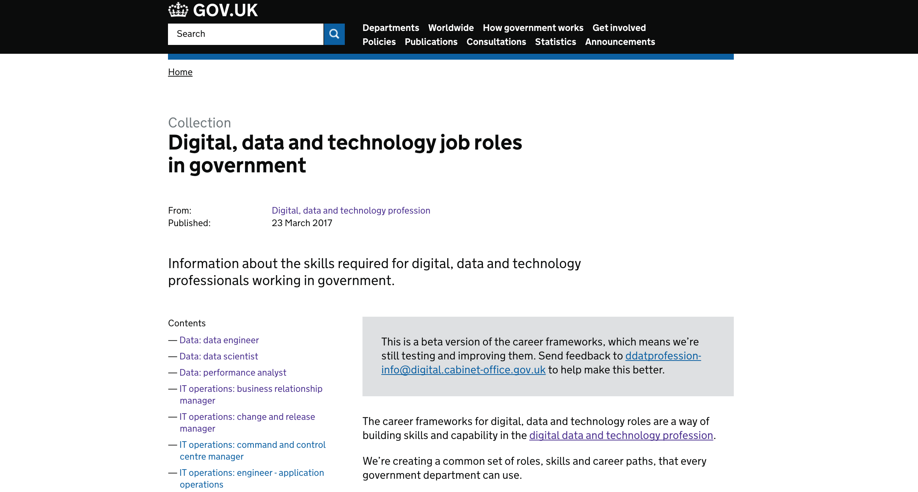

Together with strong communities of practice and opportunities for learning and development through the GDS Academy, the Capability Framework supports attraction, recruitment and retention of DDaT specialists.

The framework provides a structure for digital, data and technology job roles and career paths, detailing their typical skills. It also enables strategic initiatives for building cross-government DDaT capability by providing a common language and a coherent structure.

This provides a consistent, cross-government standard for digital, data and technology professionals working in government departments, non-government public bodies (NGPBs) and Arm's Length Bodies (ALBs).

It helps organisations understand the roles and skills they need to operate and provides individuals and their managers with the understanding of the skills they need to develop to do a good job.

The DDaT Capability Framework is integral to the work of the DDaT profession team and it’s important that your understanding of how we are building capability across government starts here.

- A brief overview of the Capability Framework provides an insight into its purpose, benefits and structure.

The Digital, Data and Technology (DDaT) Profession - everyone in any government organisation who is in a digital, data and technology role, as defined in the DDaT Profession Capability Framework is part of the DDaT Profession. These roles can be found in industry, and either have hard technical skills (Software Developer, Data Scientist) or are roles that make up multi-disciplinary teams (such as Delivery Manager and Product Manager).

Some roles can sit in more than one profession (for example, Business Analyst is in both the DDaT Profession and the Project Delivery Profession). Government organisations should decide which profession a role sits in based on what function the role is in. For example, a Business Analyst in the Commercial function may be a Project Delivery professional, whereas a Business Analyst in the Digital Function should be reported as a DDaT professional.

Practitioners may be associated with more than one profession, based on their expertise, professional aspirations and qualifications.

The Digital, Data and Technology (DDaT) Function consists of anyone or any team that provides professional services, support and expertise to departments to enable better digital, data and tech delivery. For example, an Economist or HR professional working with digital teams are not part of the DDaT Profession, but they are part of the DDaT Function.

- Read more about the functional model and the various professions in Government: list of Civil Service Professions and Functions.

The DDaT workforce data commission
We collect workforce data by working with teams to map digital, data and technology roles to the Capability Framework via the DDaT workforce commission. This is a survey that is carried out several times a year. This allows for tracking and monitoring trends in the DDaT Workforce landscape and informing the development of new capability workstreams e.g. demand, location and diversity. This gives us a consistent way to describe the workforce, and then to understand its make-up much better.
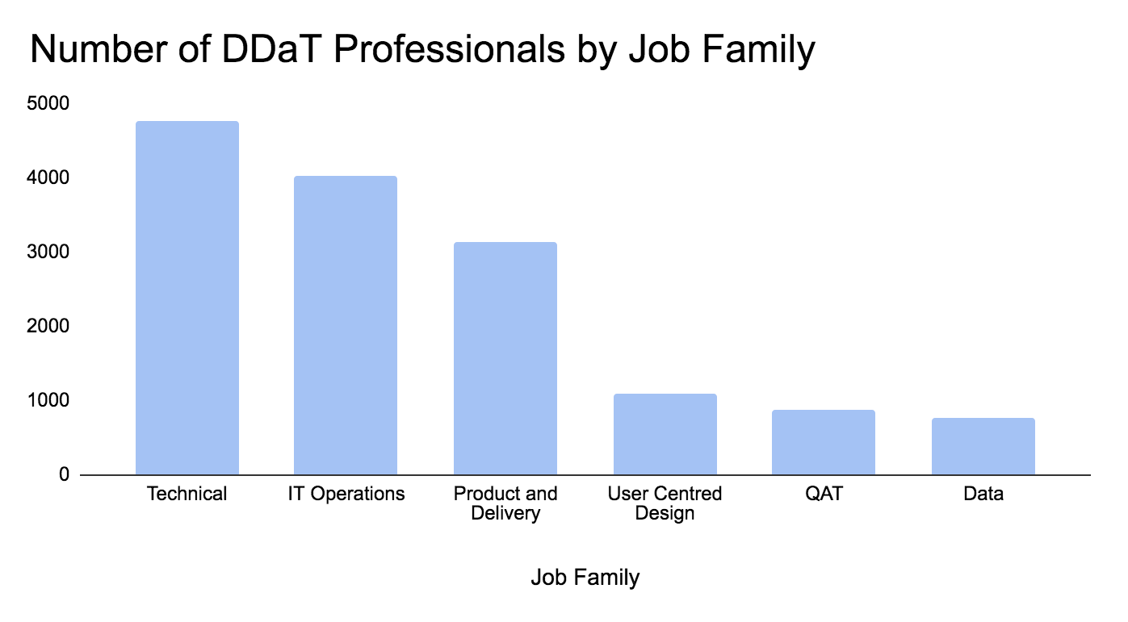

We have now validated over 15,500 practitioner roles: we know the roles, organisations and locations that they are in. The graph above shows the number of roles across government grouped by ‘job family’; a collection of related roles.

We hold data on:
- Location, allowing us to break down a regional footprint by department in each specific location
- Vacancies in departments by role, allowing us to create cross-government recruitment or talent campaigns
- Diversity information, to help us work on ways to ensure the profession reflects the society we serve
- Pay data, which helps us understand if we are rewarding DDaT Professionals appropriately to the skills they demonstrate.
With a view of the entire DDaT workforce, we can start to develop cross-government initiatives to support the needs of the Function. These might include Learning and Development strategies, recruitment approaches, or the prioritisation of the types of roles for Emergent Talent Schemes.

Longer term our ambition is to mature the use of our data by sharing it collaboratively across organisational boundaries to actively prioritise professional resource across government.

- Here are the latest presentation summaries of the March 2019, July 2019 and November 2019 cross-government Digital Data and Technology workforce commission.
(OFFICIAL-SENSITIVE: Not to be shared without prior approval of the DDaT Workforce Insights & Analytics team.)
- To see the latest insights and analysis on the Digital, Data and Technology Profession workforce, please email: workforce-insights-and-analytics@digital.cabinet-office.gov.uk
- Workforce information is collated using this survey template.
- Our workforce planning Memorandum of Understanding (MoU) must be signed before we share data across teams and is available upon request.

Please note:
Details for individual departments shown in our workforce analysis is only available to organisations who have signed the Memorandum of Understanding about this use of their workforce data.

Implementation of our strategies across government

Implementing the Capability Framework and the DDaT Pay Approach

The Civil Service Board asked that departments should implement the DDaT Capability Framework and a coherent approach to pay. This request is about bringing coherence to our terminology, creating an ability to assess skills gaps, managing talent and rewarding DDaT professionals in a way that makes it attractive to work for the government.

Over the course of the last two years our work has focussed on embedding the DDaT Capability Framework and the associated Pay Approach into the major organisations. Our primary audience for our implementation materials has been Capability Leads, HR Business Partner and Pay & Reward leads. This has meant creating organisational, structural and policy coherence through collaboration with organisations, to create consistency around how we describe the DDaT roles in government and also how we recruit, assess and reward the individuals who perform them.

Our approach to building capability through the DDaT profession audience has focussed on the growth of cross-government communities of practice through Heads of Communities (which is covered later in this document).

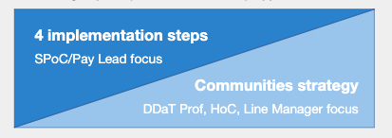

We have encouraged structural alignment through four key stages:
1. Map all DDaT jobs in the  department to the DDaT  Capability Framework | 1-3 months
2. Recruit to job descriptions  and skills | 3+ months
3. Carry out Capability  Assessments for members of  staff already in DDaT roles | 3-6 months
4. DDaT pay alignment | 6+ months

It is important to be realistic when it comes to setting timelines for
the process of adopting the DDaT Capability Framework and the Pay
Approach and this clearly depends on the size of the organisation.

We continue to publish a series of case studies, sharing the experiences of government colleagues who implement the DDaT Capability Framework. These case studies are a useful resource for teams or departments who are planning to go through the process of alignment. They include lessons learned and practical advice.

1 Mapping jobs to DDaT roles

This stage is the starting point for implementation of the Capability Framework because it provides an initial understanding of the footprint of your organisation.

The work normally entails manually mapping the roles from data held about your teams from various HR sources into the DDaT Profession Capability team’s mapping spreadsheet, which is the same tool that is used for our workforce commission data. This exercise normally throws up some challenges: some roles are difficult to map, you may have ‘hybrid’ roles (people performing multiple duties) within your organisation or you may discover teams / people that you didn’t even realise were performing DDaT roles.

From a department perspective this gives you a consistent view of your workforce and an ability to make local decisions relating to vacancies, strategies around diversity and inclusion, pay policy and location. By signing our Memorandum of Understanding (MoU) your data will be uploaded to our workforce planning tool and can be viewed alongside the data of other organisations, giving you the ability to understand how your organisation compares to others.

- Workforce information is collated using this survey template.
- Guidance on mapping roles to the DDaT Capability Framework
- Examples of jobs mapped to DDaT roles and some that should not be!
- Download the full Capability Framework as a filterable spreadsheet (v1.1 2018-04-28) which is handy for comparing roles
- For a version of the Capability Framework to import directly into your organisation’s data-systems, integrate a data-feed from the DDaT Profession capability framework register.

2 Recruitment of talent aligned to role descriptions
and skills

It would seem obvious to suggest that the easiest way to align to the DDaT Capability Framework is to map all new positions to the framework and to recruit using the framework’s role descriptions and skills.

However, the volume of roles currently advertised that do not align to the framework suggests a more complex organisational challenge, especially for larger teams. In order to support organisations in creating consistency around the hiring process, we have created a library of aligned job description templates for every role. These templates do not contain the job-specific detail relevant to a department/organisation that would need to be included before grading a job in the JEGS process. Thus the templates can be adjusted to meet your needs.
Success Profiles - Technical skills assessments
Success Profiles replaced Civil Service Competencies as a way of assessing candidates during recruitment. Candidates will still be evaluated against a range of elements, but this will now include a new assessment, ‘Technical - the demonstration of specific professional skills, knowledge or qualifications’. Organisations can assess candidates’ technical skills against those set out for the role in the Capability Framework.
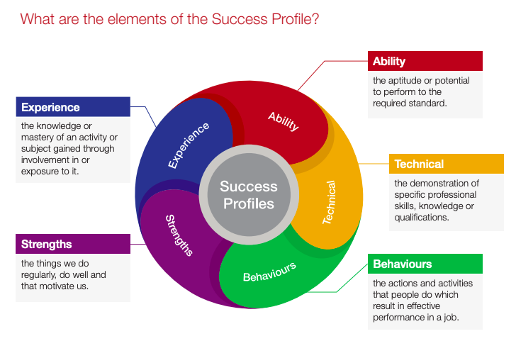
The GDS Recruitment Service
The DDaT Cross-Government Recruitment Service in GDS supports the DDaT profession to attract the best candidates for roles across government. The team can support recruitment for all grades including Senior Civil Service roles and offers differing levels of service, depending on your needs. The service includes:
- designing recruitment strategies: advising best routes to market
- branding advice - producing the best job ads and descriptions to attract the right candidates
- access to other government department's reserve lists
- identifying diverse panel members
- joint cross-government campaigns.

Additionally we are looking at how we can support other departments grow their Diversity and Inclusion Agenda within recruitment, we can do this by offering Inclusive Recruitment Assessments reviewing job descriptions, adverts and branding.

We also offer recruitment training in:-
- Unconscious bias in recruitment
- 9 common biases in recruitment
- how to mitigate
- how to challenge the business
- how to challenge yourself
To find out more contact the GDS DDaT Recruitment Team.

- The DDaT Recruitment Toolkit DDaT Profession recruitment toolkit provides guidance on how to define new Digital, Data and Technology (DDaT) vacancies and advice on how to recruit DDaT roles.
- Using Success Profiles in recruitment
- Job descriptions for all DDaT Capability Framework roles. Download the set of 151 job description templates for all the DDaT Profession role-levels.
- Please contact the recruitment team for more information on their services: ddat-recruitmentsupport@digital.cabinet-office.gov.uk
- SCS recruitment materials and services are also available upon request as we continue to develop our SCS Capability Framework.

3 Assessing Skills

A skills assessment is a way of evaluating an individual's skills against those set out for a specific role level in the DDaT Profession Capability Framework. Skills levels are provided for each skill:
- Awareness
- Working
- Practitioner
- Expert

Practitioners and their line managers can use capability assessments to:
- evaluate the individual’s skill levels
- identify skill or knowledge gaps
- inform decisions about career development
- gauge demand for learning and development interventions
- provide supporting evidence for capability-based pay awards where appropriate.
During the assessment line managers and/or assessors should:
- work through each of the skills and skill levels required for the role level, as listed in the Capability Framework
- look at the work the individual is doing and draw on their previous experience to evaluate what levels the individual is currently at
- review and agree on areas of learning and development
- document the results of the assessment.

The Profession’s Capability team does not currently have a cross-government online tool to collate this data although some teams are already using these locally. We have created manual assessments for each role that can be downloaded from the Knowledge Hub portal alongside guidance and case studies to help implement. Exactly how an organisation undertakes skills assessments will depend on the needs of the department.

Organisations are also developing methods to assess teams to inform functional Learning and Development strategies using the DDaT Capability Framework to assess individual skills.

- Skills assessment guidance
- 20 files of career path diagrams for all 36 DDaT roles - as a set of pdfs; as a set of editable Powerpoints
- Download an example of assessment template (Developer)
- Download an example of a completed assessment (Technical architect)
- Download a set of 151 assessment templates (one for each role-level)
- Download a zip file of a draft outline presentation on capability assessment to amend/use when briefing staff.
- Skills assessment case studies COMING SOON…
  - Highways England, Cabinet Office, Companies House
  - Home Office

4 DDaT pay alignment

Pay is just one area that can help with attraction and retention. The current pay landscape differs widely across organisations and so we want to address this once for the Profession. The DDaT Pay Approach supports that attraction and retention of individuals by ensuring DDaT professionals are rewarded with a consistent approach for the same type and size of role with insights from the wider labour market in mind, regardless of the organisation they work in.

The DDaT Pay Approach aims to provide a simple, effective, and consistent guidance on pay for Civil Service DDaT professionals. It is designed to help attract, recruit and retain specialist skills by accounting for reward levels in the wider tech sector.

In line with the Civil Service Workforce Plan, the civil service continues to explore opportunities for greater coherence to reward. The DDaT Pay Approach supports this ambition and enables a consistent way to reward DDaT professionals based on their specialist skills with objective measures within the existing flexibilities of the organisation’s delegated pay.

The DDaT Pay Approach is made up of 2 things:-
1. Pay guidance for each role in the DDaT Capability Framework
2. DDaT Pay Framework for ‘critical roles’

Pay Approach Guidance
This guidance is available upon request through your organisation’s Pay & Reward Lead. It provides organisations a coherent way to award pay to all DDaT professionals using a capability-based mechanism, with a maximum (the maxima) for each level of capability: Developing, Proficient and Accomplished in a role.

We do not provide a pay range (or bottom limit for pay), and therefore it can be applied within your organisation’s own pay flexibilities.
This may mean adjusting your policies about starting salaries within your own existing pay scales and payment of allowances. You may also need to consider awarding more money based on individuals demonstrating improved skills using the guidance provided.

The guidance doesn’t expect organisations to pay to the level of the maxima as a standard as this may not be appropriate to local conditions, rather the top of the range is provided to create a coherent approach between departments, that accounts for the labour market while avoiding a “race to the top” in reward terms

This approach improves access to fair reward, based on market benchmarking and demand across government. It provides a mechanism for capability-based reward to support retention of talent. We also aim to reduce grade inflation. Higher grades come with extra responsibilities that may not be suitable for all practitioners (e.g. broader organisational leadership commitments). This approach allows for practitioners to be graded appropriately while still paying them as required accounting for their assessed level of capability.

The Pay Framework
This approach is a separate DDaT pay mechanism (with pay ranges) that allows you to recycle contractor pay (or programme spend) into Civil Service salary pay through an acknowledged HM Treasury business case process. It applies to critical roles (roles we have identified as the most difficult to fill) at SEO, G7 and G6 as defined within the guidance.

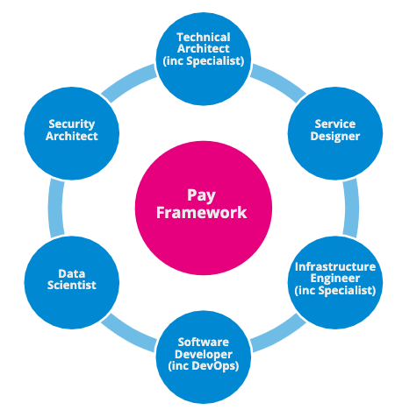

The guidance provides capability based enhanced pay ranges, common allowances, and details of how to reappropriate contractor ‘spend’ to fund DDaT civil servants. Naturally more difficult to fill roles command a premium salary in the job market and our guidance reflects this.

Due to the nature of the capability based pay approaches described within both the Pay Approach and the Pay Framework guidance, implementation requires close alignment to skills assessment.

Other pay related materials and services
For teams interested in understanding the impact of the Pay Approach guidance and / or whether they have a Pay Framework business case we offer a pay modelling service that looks at existing levels of pay in your organisation and the impact on salaries should the guidance be applied. This also helps organisations understand and plan their funding approach to implementation.

In addition to the above guidance, we also provide DDaT Profession Indicative Grades for job role levels which show the most common grading for DDaT job role levels based on current data across government. Please note: this is not an official grading guidance, since the DDaT Profession cannot grade all DDaT roles. This is because the grading process is for jobs rather than generic roles. Each organisation should carry out its own evaluation of its job roles through the JEGS process. It is possible that a job may be evaluated above or below the grades indicated.

It is worth noting that the Pay Approach guidance is seen as an innovative and pioneering pay model across government professions. We are learning about what works and our reward case study: Companies House - Using the Digital, Data and Technology Capability Framework explains how implementation of the Pay Approach helped to improve staff engagement and reduce turnover.

Detailed Pay Approach materials and guidance are treated as OFFICIAL-SENSITIVE and are only available upon request through your Pay and Reward Lead.

- The Pay Approach Guidance V1.1 provides an overview of the approach.
- Indicative grades for job role levels which show the most common grading for DDaT job role levels based on current data across government.
- Case Study: Companies House - Using the Digital, Data and Technology Capability Framework.
- JEGS process.

Available upon request through your Pay and Reward Lead:
- the Pay Approach full guidance
- the Pay Framework Summary which explains more about the Pay Framework.
- the Pay Framework Toolkit which provides guidance to help you create a business case, including examples and business case templates.
- Pay Modelling assistance is offered to help determine whether you have a valid Pay Framework business case. Our approach is also available as a self-serve toolkit - please ask your Pay and Reward Lead the team.

Future changes to the Pay Approach

In Quarter 4 of each financial year, we undertake an annual review of DDaT pay benchmarking data to maintain alignment to market trends. We monitor industry salaries and other changes reflected in the market data, including assessing demand for roles in government, as reflected in the DDaT workforce data we’ve been collecting throughout the financial year. While the capture of this data is routine throughout the year, if your organisation has particular concerns to be raised in this review please get in touch with us via our shared mailbox.

- Find out about our Pay Approach review and find out how to get involved to inform benchmarking in the future.

Future changes to the Capability Framework

The Capability Framework provides a common set of roles, skills and career paths that all government organisations can use.

Our approach is to keep the framework up to date by looking to industry trends to identify the gap between the current reality of the DDaT workforce and what is required in a future state. This does not mean reflecting the existence of every role as it exists in the function today, nor do we intend to include detailed descriptions of the responsibilities of every DDaT professional or smaller scale specialist roles.

We drive changes through requests from our communities of practice.

To request changes to the Capability Framework or to understand the status of all requests, please see the resources on the DDaT Knowledge Hub.
- Process for requesting changes to the Capability Framework
- Request a change to the Capability Framework
- Status of requests for changes.

Building capability through our communities

Communities of Practise

A community of practice (CoP) is a group of people who share a common concern, a set of problems, or an interest in a topic and who come together to fulfill both individual and group goals.

In the DDaT profession these usually organised around roles in the DDaT Capability Framework, or a collection of them. So there are Product and User Research communities of practice as well as a User Centred Design community. UCD is a collection of various design and research roles that contribute to User Experience (UX).

We believe ideally that the groups are organically run and self organising, connecting practitioners across government to share best practice, discuss challenges and support each other to build capability. The DDaT Profession Capability team supports the development of communities of practice.

We want to increase the visibility of communities of practice and allow individuals to tap into their support network. We’re helping organisations without communities set them up and putting different organisations’ communities in touch with each other.

We work with a number of Heads of Communities of Practice in GDS to share better practice and ideas about how best to engage and support learning in their community.
We want all individuals within government to share their ideas, their best practices and both their formal and informal learning. This aligns to the 70:20:10 learning and development approach: 70% of a person's learning at work is ‘on the job’, internal, and experience-based; 20% comes from interacting with fellow employees; and 10% is the result of formal training.

By working collaboratively we aim to enable all individuals within government to play an integral part in building the DDaT profession, increasing expertise and capability, within their departments but also across government.
This makes government a great place to work for all of us!

Visit the communities page on GOV.UK Service Manual. You’ll find details on how to access specific community networks, as well as information on how to set up or start your own community. There’s email addresses as well as links to community channels, which will enable you to get in touch with the GDS DDaT Profession team, as well as fellow DDaT practitioners around government.

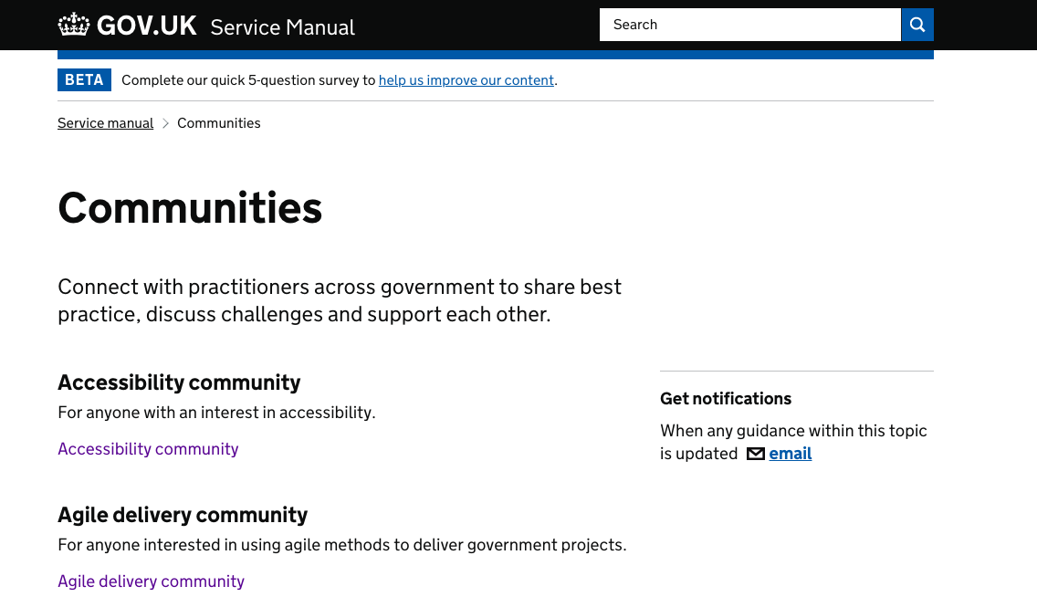

Many of those communities are led by cross-government “Heads of Community”, which are formal paid roles, based in GDS.

The heads of those communities often run cross-government workshops, and support general engagement across government, so you can also contact them directly to find out information about specific community activities.

By sharing your community or ‘heads of’ contacts with us, we are able to connect you better, especially in the cross-government community events space. We would encourage you all to ask your community leads/heads of community to sign up to the DDaT Knowledge Hub portal, and to edit and update our events data which is held there. The more accurate and available the information is, the more valuable it becomes to all of teams working to build capability for the DDaT Profession.

Our DDaT profession case study series includes an explanation of how MOJ Digital has used communities of practise to support their implementation of the Capability Framework.
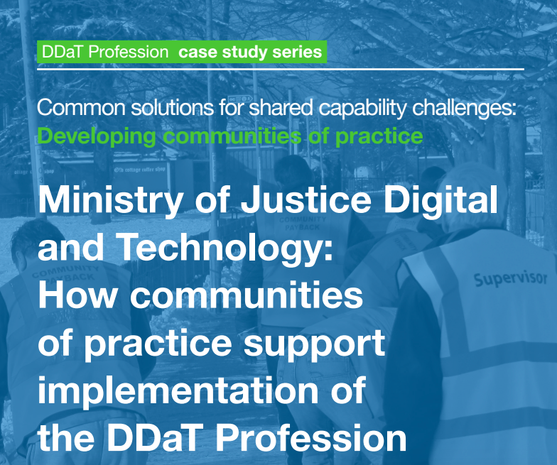

The Product Management community

The Product Managers space is growing in government and people learn best from doing. To support people interested in product management and upskilling Product Managers, we have developed a number of resources to help someone on their product learning journey. This is everything from reading lists to supporting the development of Associate Product Managers (APMs) and Product Managers (PMs). We also have a resource to help senior Product Managers in their leadership skills as well as other useful resources that can be downloaded from K-Hub.

- Visit the Communities page on the GOV.UK Service Manual
- Setting up a community guidance document
- See the latest cross-government Community Events
- Current status of Communities of Practice in departments/organisations (update if you know different for your department/organisation)
- Here is a list of current Heads of Communities of Practice at GDS (which includes some who have responsibility for x-Gov communities).
- Product Management community content on KHub
- To find out more about the latest developments in communities of practice across government, email: ddatprofession@digital.cabinet-office.gov.uk
- Case Study: MOJ Digital - how communities of practise support implementation of the Capability Framework

Resources for Senior Civil Servants (SCS)
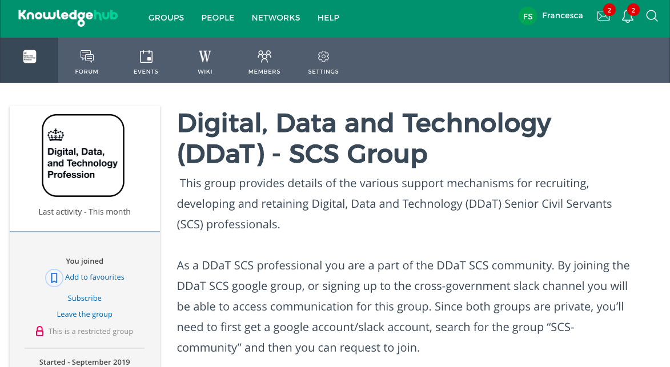

We have recently started to develop digital capability of DDaT Senior Civil Servants (SCS) across government by creating a DDaT SCS Community to improve networking opportunities. This came out of various DDaT SCS induction events in which individuals expressed a need to connect and network with each other better. We have built a contact list of our SCS to establish a community for this group on Knowledge Hub (Khub).

The Khub page is a secure private group for DDaT SCS only and provides contacts of each member and a forum for conversation. Over time we will also have information on the resources and support that GDS and the DDaT profession team can provide for SCS.

DDaT SCS Capability Framework
Working with senior stakeholders in DDaT and Civil Service HR across government we have developed an alpha version of the DDaT Capability Framework for the SCS.

This currently sits separately from the DDaT Capability Framework for delegated grades. The SCS Framework consists of the commonly seen DDaT leadership role groups across government provides an overview of each role group as well as the leadership behaviours and technical skills we expect to see of our leaders in these roles. It was designed to be coherent with the wider Success Profiles approach across the Civil Service.

The DDaT SCS Capability Framework will offer consistency in the design and recruitment into DDaT leadership roles, as well as being a useful product for our digital leaders looking to develop their capability or for G6/7s looking to progress to SCS.

Additionally we are also setting up talent forums for Director and Deputy Director roles. These forums will bring those managing our Digital leaders into a room to discuss development opportunities and requirements on a more regular basis.

The forums will also allow us to understand succession planning across the profession and any upcoming resourcing needs for departments, allowing us to inform strategic managed moves where possible.

- Please contact our Talent team to ensure that we know who your SCS personnel are and how we can connect them.
- SCS leaders may request access to SCS Knowledge Hub.
- Please contact our DDaT cross-profession recruitment team if you’d like help with your SCS campaigns.

Emerging Talent

Emerging Talent Offer
The Emerging Talent Team offers support to departments to use talent development to build capability and meet their DDaT business needs. As well as centrally managing multiple DDaT talent development programmes (see details below), the team provides guidance and works with departments to identify and support common cross-government requirements.

DDaT Fast Stream programme
The Digital, Data and Technology Fast Stream is a leadership talent development programme, delivered in partnership with CSHR, designed to increase digital capability.

Participants on the DDaT Fast Stream you work alongside departmental expertise to design, build and run services which are used by millions of people every day. Services such as register to vote, apply for a driving licence or apply for a UK passport.

Software Developer Accelerator Apprenticeship
The Software Developer Accelerated Apprenticeship, is a level 4 apprenticeship programme that focuses on retraining civil servants, who are already skilled in their own field, with new technical skills.
The programme shortens the traditional training period (for this apprenticeship standard) of 24 months to just over a year, and is specially designed to allow apprentices to undertake a 12-week training bootcamp and then spend the remaining months on placement in their department, putting their new skills into practice.

New CS HR Apprenticeship
Coming soon (2020) a new DDaT Profession led level 4 apprenticeship programme, delivered in partnership with CSHR.

- Find out more on the DDaT Fast Stream web site including the FastStream application process

GDS Academy

Government is changing. Digital is transforming how government works. The GDS Academy teaches public sector professionals the digital skills they need to transform public services and embrace this change. To work more efficiently and creatively, and to build the best possible services for users, whatever their level of technical expertise.
The GDS Academy offers a range of courses, with introductory sessions for non-specialists, a number of working level courses for people in digital roles and training for leaders responsible for digital services.

The Academy is part of the Digital, Data and Technology Profession and over 10,000 students have been on GDS Academy courses.

- Find out about the GDS Academy and its courses.
- You can also read our privacy notice.
- GDS Academy course descriptions

The GDS Academy has a partnership with the Scottish Government. Visit the Scottish Digital Academy website to find out about courses.

Tools and guidance on Knowledge Hub
There are lots of useful DDaT Capability resources on Knowledge Hub. There are practical resources on capability assessment, DDaT career paths, and more.

See details on how to sign up to Knowledge Hub, and what's available.

Keeping in touch
Remember that we rely on you to connect us with new colleagues, forward our materials or introduce us to people who’ll benefit from an invite to our events. So if you think a colleague would benefit from this starter pack information please forward it on.

If you have any questions, please contact the DDaT Profession Capability DDaT Profession Capability team at GDS. at: ddatprofession@digital.cabinet-office.gov.uk

We produce a Capability Note to keep you abreast of our news every three to four weeks.
Subscribe to receive our Capability Note.

Previous Capability Notes can be found on Knowledge Hub.

To see the latest insights and analysis on the Digital, Data and Technology Profession workforce, please email: workforce-insights-and-analytics@digital.cabinet-office.gov.uk

Please contact the recruitment team for more information on their services: ddat-recruitmentsupport@digital.cabinet-office.gov.uk

