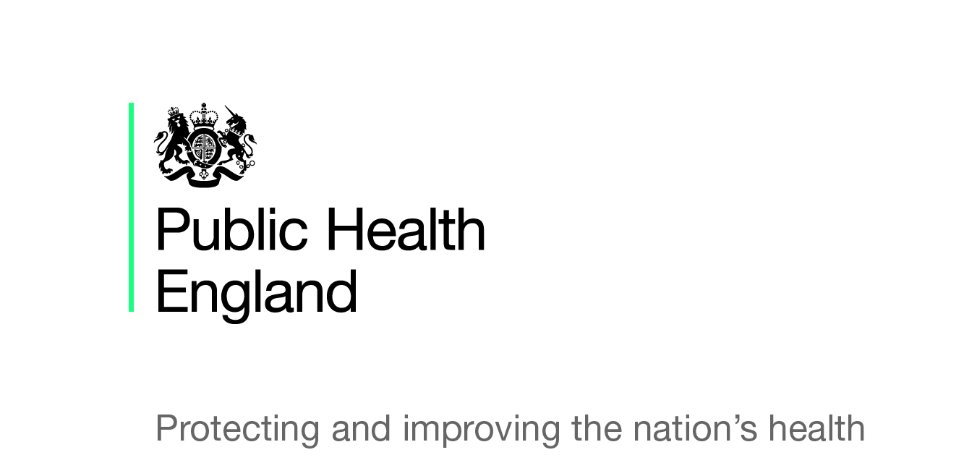

Making Every Contact Count

Briefing produced by Public Health England’s East of England Health & Wellbeing Team - Sept 2019 (V1.01)

This briefing paper has been produced by Public Health England’s East of England Health and Wellbeing Team. It is designed to provide easy access to key reference points and useful resources around the Making Every Contact Count (MECC) agenda and will be updated on a regular basis as new information becomes available. The information in each section is presented chronologically, with the most recent first.

What is MECC?

MECC is an approach to behaviour change that utilises the millions of day-to-day interactions that organisations and people have with other people to support them in making positive changes to their physical and mental health and wellbeing. MECC enables the opportunistic delivery of consistent and concise healthy lifestyle information and enables individuals to engage in conversations about their health at scale across organisations and populations. You can find out more information on its own website here.

National policy and reports

MECC: Developing Plans to Implement MECC in NHS Organisations in Cheshire and Merseyside
This insight report with senior healthcare leaders in Cheshire and Merseyside (July 2019), explains the current barriers and ways of supporting trusts to improve their MECC offer. It makes recommendations to health system leaders, commissioning organisations and NHS trusts.

NHS Standard Contract 2019/20: Service Conditions
This contract (March 2019) requires providers to develop and maintain an organisational plan for MECC, in accordance with its’ principles and guidance. This is detailed in Section SC8.

Making Every Contact Count: Consensus Statement
This consensus statement (April 2016) describes the commitment of several organisations, including PHE, NHSE, Health Education England and others, to work together to maximise support for population behaviour change, and help individuals and communities significantly reduce their risk of disease. This statement has been developed to provide clarity on what is meant by MECC, to highlight the evidence base and to illustrate the population and workforce benefits of this behaviour change approach.

Healthy Conversations and the Allied Health Professionals
This report (March 2015) details the willingness to engage in conversations about healthy lifestyles with the Allied Health Professionals (AHP) patients, based on a survey of over 1,000 AHPs. Overall willingness was there but several challenges were identified and a number of recommendations to overcome these were noted.

Data, guidance, infographics and toolkits

All Our Health
The PHE All Our Health framework (first published 2015, but evolving with latest updates in May 2019) is a framework of evidence and call to action to all healthcare professionals in England to help them understand and maximise the impact on improving health outcomes and reducing health inequalities. PHE has published a resource about the framework and subsequent guidance around applying All Our Health to a variety of areas of health improvement, health protection, healthcare public health and the wider determinants of health, such as social prescribing (which includes MECC), obesity, physical activity, workplace health, CVD and NHS Health Checks as well as many other topics.

Making Every Contact Count: Implementation Guide
This tool (July 2018) has been developed to support organisational readiness and aid the implementation of MECC. This resource will help organisations when assessing their current position as a health-promoting organisation and help to identify any areas for further input or improvement. It can also act as an implementation checklist.

Making Every Contact Count: Quality Marker Checklist for Training Resources
This resource (July 2018) provides quality markers and a checklist that organisations can use to assess their MECC training programmes or to use as a guide to develop a new training package. The quality markers are split into 3 sections: context of the training (why MECC?); skills and knowledge (how to deliver MECC) and evaluation (is it working?). Each marker has a set of indicators detailing what should be in place.

Everyday Interactions: Measuring the Public Health Impact of Healthcare Professionals
This guidance document (June 2017) focuses on four of the key healthcare professions within the wider workforce: nurses and midwives, dentists, allied health professionals and pharmacists and aims to support these healthcare professionals (HCP) as they record and measure their public health impact. It includes a toolkit consisting of ten impact pathways covering key public health priorities (e.g. obesity, smoking etc) to help HCP record and measure the activities they are already undertaking.

Making Every Contact Count: Evaluation Framework
This evaluation framework (March 2016) has been developed to support the implementation of MECC. It is intended for use by local MECC programme managers, operational leads and those who have an oversight of lifestyle services delivery within their role.

NICE Guidelines and Quality Standards

NICE have guidance and quality standards to help support people to take action to improve their lifestyle, which is key to MECC and can be found by browsing the lifestyle and wellbeing area of the website. The behaviour change topic page is particularly relevant.

NICE MECC Resource for STPs/ICSs - This resource aims to support those within STPs/ICSs in navigating NICE guidance, standards, tools and shared learning on the NICE website, relating to MECC.

NICE Behaviour Change: Individual Approaches [PH49] - (January 2014, last updated in March 2019) - This PH guideline covers changing health-damaging behaviours using interventions such as goals and planning, feedback and monitoring and social support. Recommendations include details on ‘very brief’ and ‘brief’ interventions and training for staff.

NICE Behaviour Change: General Approaches [PH6] (October 2007, last updated in November 2017) - This PH guideline covers a set of principles that can be used to help people change their behaviour. It is aimed at practitioners to use these principles to encourage people to adopt a healthier lifestyle.

Initiatives and Campaigns

PHE Campaign Resource Centre
You can sign up to the PHE Resource Centre where you can see all of PHE’s campaigns, including campaign resources which you can download or order free of charge.

PHE One You - Social Marketing Programme
Launched in March 2016, ‘One You’ encourages adults to take part in an online health quiz, called ‘How Are You?’, which helps them reassess their lifestyle choices. After completing the quiz, individuals can receive email reminders and resources to motivate them to make changes to lead a healthier lifestyle. ‘One You’ has its own website with a range of resources and free apps. In the first year of its launch, there were 1.34 million completions of the quiz. Promotional materials can be downloaded and ordered for free from the PHE resource hub.
Under the banner of ‘One You’, PHE has launched several campaigns covering different lifestyle choices and changes that can be made:
Drink free days – PHE in association with Drinkaware, launched this campaign in September 2018 to help people, particularly 45-64 year olds, cut down on the amount of alcohol they are regularly drinking and to highlight that having more drink free days can reduce risks of serious conditions like CVD and improve their health.
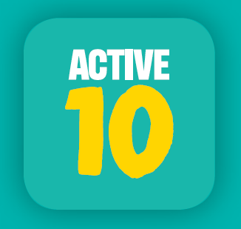
Active 10 – Initially launched in March 2017 and re-launched in June 2018, this PHE campaign aims to combat physical inactivity and lower the risks of serious illnesses such as heart disease, by encouraging adults to incorporate more physical activity into their daily lives, by going for a brisk ten-minute walk (or more) each day.
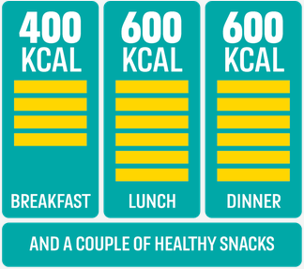
400-600-600 – Adults are consuming on average an extra 200-300 calories per day. This ‘calorie creep’ contributes to two thirds of adults being overweight or obese, which can in turn lead to serious CVD conditions. This PHE campaign was launched in March 2018, to help adults manage the ‘calorie creep’ by providing simple tips to help them make healthier choices whilst on the go. The aim is around 400 calories for breakfast, 600 for lunch and 600 for dinner, plus a couple of healthier snacks and drinks in-between.
Stoptober – Originally launched in October 2012, this PHE 28-day stop smoking challenge, encourages and supports smokers across England towards quitting for good. There are lots of ways to quit and Stoptober can help people choose what works for them and provides free support along the way.
Heart Age Test – This tool is a collaboration between NHS, PHE, the British Heart Foundation and UCL. It was relaunched in September 2018 and is an ‘always-on’ campaign. This simple online test helps individuals compare their heart age to their real age and explains the importance of knowing their blood pressure and cholesterol numbers. The test can still be completed if these numbers are not known. As part of the results, it also provides individuals with advice on how to lower their heart age and reduce their risk of heart attack and stroke.

MECC Community of Practice
The purpose of the MECC community, hosted on Facebook, is to offer information and support to individuals/teams who aim to implement MECC; share ideas, learning and experiences around implementation and training in MECC and to raise the profile of this approach.

What Matters to You
‘What Matters to You’ day aims to encourage and support more conversations between people providing health and social care and the individuals, families and carers who receive that care. It aims to shift the focus from ‘what is wrong with you’ to ‘what matters to you.’ It’s an international campaign and Scotland have taken this up for the last two years and provide a summary report for 2018 on their website.

Training opportunities

All Our Health: e-Learning for Healthcare
PHE and Health Education England have developed and launched new bite-sized e-learning sessions to improve the knowledge, confidence and skills of healthcare professionals in preventing illness, protecting health and promoting wellbeing. They cover top public health priorities and contain signposting to trusted sources of evidence, guidance and support to help healthcare professionals embed prevention in their everyday practice.

MECC: e-Learning for Healthcare
This programme is in partnership with Health Education England, Department of Health and Lancashire Care NHS Foundation Trust. The e-learning is designed to support learners in developing an understanding of public health and the factors that impact on a person’s health and wellbeing, emphasising how asking questions and listening effectively to people is a vital role for us all.

Other briefing documents in this series

There are several briefing documents in this series which may be useful and will be updated on a regular basis. These include:
- Cardiovascular Disease
- Dementia and Healthy Ageing
- Obesity Prevention
- Physical Activity
- Sexual Health
You can click on the links above to download each document or visit the PHE East of England Group on the KHub to view all the documents in the series and other useful resources.

