10 ways to get the best out of the wiki
A wiki is a webpage which anyone can edit. All group members can make and view changes to a wiki page. No one needs to collate and consolidate various versions. This makes wikis robust, open-ended and collaborative. You can compare edited versions of a wiki page and revert back to previous versions, avoiding loss of any work which may become relevant.
- Record meeting minutes – record minutes directly during meetings (online and offline) allowing attendees to keep track, and have an instant record available for anyone to add to.
- Signpost key content – create a contents list for your group to signpost members to relevant threads, library items, events, etc. Organise content by topics and themes making them accessible from a single place. See wiki example 1.1 below.
- Coordinate events – develop agendas collaboratively and create delegate lists allowing virtual organisation of events.
- Organise plans and ideas – avoid unnecessary emails and build plans and ideas together and store everyone’s contributions and amendments in one single place. See wiki example 1.2 below.
- List facts and frequently asked questions (FAQs) – create and build facts and FAQs collaboratively in one single place, and point people to them.
- Manage project development and actions – update project work areas, keep track of development and actions, test new ideas and get feedback from everyone to inform decisions.
- Report issues – record on-going issues for reporting, and pick up duplicate issues easily and identify related issues quickly.
- Create useful resources – store reference lists of contacts, documents, external links and websites, instructions, checklists, etc. for all members to easily view and update. See wiki example 1.3 below.
- Build collaborative dictionaries – list an A-Z of common terms used in your work area, for members to view and add to, building a group vocabulary. See wiki example 1.4 below.
- Display operational manuals – save guides and manuals in a wiki making it easy to update when things change, ensuring members have access to the latest version all the time.
Wiki example 1.1 - Signpost key content

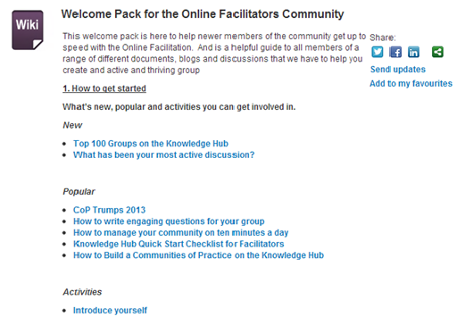

Wiki example 1.2 - Organise plans and ideas

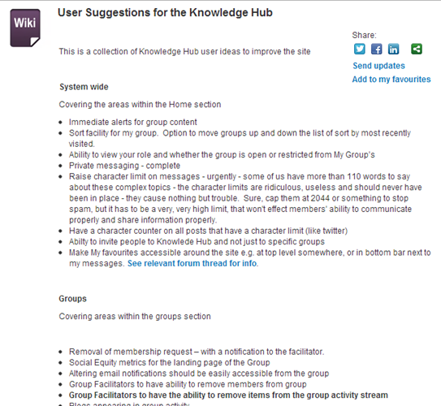
Wiki example 1.3 - Create useful resources

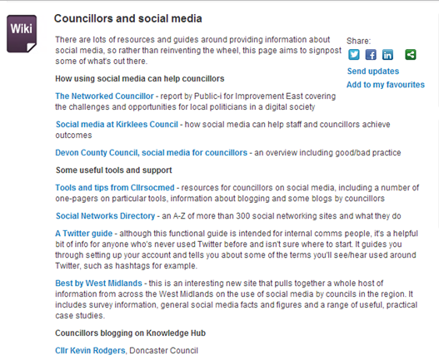

Wiki example 1.4 - Build collaborative dictionaries

